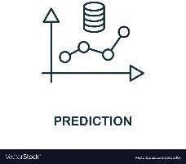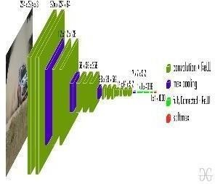

FIRE

CNN Model

TESTING DATASET

.

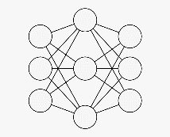**Technical Architecture:**

Training neural network with dataset

IMAGE DATASET

TRAINING DATASET

NO FIRE

P Architecture

r o j e c t

|  |  |
| --- | --- |
| Date | 18 NOV 2022 |
| Team ID | PNT2022TMID39009 |
| Project Name | Project – Early detection of forest fire using deep learning |
| Maximum Marks | 4 Marks |

D

e s i g n

P

h a s e

- I I

T

e c h n o l o g y